Erica Slye
Global Ethics Final Paper
Technology in the Workplace: Does it Enhance or Inhibit?
Virginia Polytechnic and State University
May 8, 2017

Abstract:
When one thinks of the term ‘global ethics’, they think big picture, which makes sense hence the word ‘global’. The things that come to mind are on the national and continental level, concerning how these big picture relations all contribute to the earth as whole. However, global can be broken down into smaller sectors, and I believe that one cannot truly and accurately comprehend concepts at the global level until they can wrap their head around these smaller ideas. These sectors can include things at the state level, community level, within a family, or even one’s daily workplace. This paper addresses the latter of those sectors; the workplace, but more specifically the technology that affects the workplace and how one might be influenced by this, knowingly or not. The paper will address not only the ethics of technology in the workplace, but whether or not technology enhances or inhibits it.
Introduction:
Many people feel very strongly about this topic, some saying that technology destroys jobs and keeps people from reaching their full potential while others consider it necessary to be successful today. There are some people that believe that the individuals that make robots should be let go from their jobs because the robots that they are making are taking away people’s jobs. They use the argument that they should lose their job before they make something that takes other people’s jobs, but is this a question of ethics or simple competition within the workforce? Many people think that technology is destroying the workforce, inhibiting people from getting jobs and being successful. The other side of this believes that technology enhances the workforce, allowing for people to have a more rewarding career. While the increase of the use of industrial machines, or robots, does offset the jobs available in lower trade areas, this is not the only example of technology in the workplace. Overall, technology enhances the workplace due to an increase in productivity, development, and human capital; as well as access to more specialized jobs that are created due to technology in the workplace.
Body:
Prior to analyzing the ethics of technology in the workplace, it is important to comprehend what technology is actually defined and classified as. Technology can be defined in three different ways. The first defines technology as the practical application of knowledge, especially in a particular area¹⁰. Secondly, it can be defined as a manner of accomplishing a task, particularly using technical processes, methods, or knowledge¹⁰. Finally, technology can be considered as specialized aspects of a particular field or endeavor¹⁰. This is paramount to the argument for technology in the workplace because, as one can see, robots or industrial machines are not in the definitions above. There are so many sectors of technology, but they all involve this idea of knowledge. Technology cannot exist without the person that makes it or thinks of it. Therefore, technology cannot take over jobs because people and their ideas are needed and required in order to create, oversee, and modify technology. Technology does not take jobs; they are simply redirected to another field, and this has been happening for decades, even dating back to before the industrial revolution⁷. In the workplace today, people need technology and technology needs people.
From an outside perspective before doing copious amounts of research, it seems that individuals were against technology for two reasons. First being that they believed people were losing their jobs due to the increased creation and use of technology. Secondly, they did not fully understand the benefits and ramifications of employment due to technology. However, technology can be seen as something that has always been there to fix the problem, and in this case, there is a problem and people are looking for something to blame. Technology is fixing the problem by being the problem; it gives people something to criticize when something goes wrong ².
A larger argument against technology in the workplace is that it takes replaces people in the workforce, therefore resulting in less available jobs in the future. This is then attributed to the use of industrial robots. By 1990, the existence of industrial robot had increased from 50,000 to 100,000 just in the United States, resulting in a net loss of 100,000 jobs ¹⁴. While this is a valid statistic and claim, it is rather biased. First, as mentioned earlier, technology does not just include industrial robots, rather so many other sectors that allow for the different jobs and workplaces to effectively function. Secondly, these jobs that were replaced by industrial robot not only have allowed the company to increase in productivity and therefore profit, but it has opened up just as many other jobs in different areas that are created due to the creation and development of technology¹¹.
Technology development allows for higher productivity and higher profit. The increase of this trend has been taking place since the industrial revolution⁷. Data compiled by management consultants Deloitte from the census data for England and Wales stretching back to 1871 suggest that the growth of jobs in the creative, care, tech and business service industries have more than offset the loss of jobs in the agricultural and manufacturing sectors⁷. As the creation, development, and use of technology has increased, this has allowed for exponential growth in production and efficiency within companies. As shown by graph 1, the yield of wheat increases dramatically as time continues. The title of the graph references ‘developing’ countries, which are commonly mistaken as impoverished or third world countries, rather the United States could also fall under this category. It was and still is a developing country, but not necessarily related solely to wheat yield, but also to the development in technology. So, as shown by this graph, as time continues, technology is advanced, therefore allowing for the greater production of wheat, hence a higher income simply from higher production levels.
As far as getting a job due to the increase in technology use and development, there are two sides to this as well. The first being due to the relocation of jobs into more specialized fields, many of these jobs require some education or specific training. For those that are unable to afford an education, this could be detrimental to their career. If they cannot afford to get an education, they potentially will have difficulty getting a job, and if they cannot get a job, they are unable to pay for an education, which will keep them from getting a job, and it just results in an endless loop. However, this is not the case because there are still many specialized trades that do not require an education, rather they do training when an individual first begins the job. For example, although contrary to conventional wisdom, the trend in health care is beginning to shift work away from the most educated workers towards less educated workers¹. Furthermore, employees gain much critical knowledge about new technologies through experience on the job and such learning often does not require a high degree of education¹. Many companies want to personally train and mold their employees to work and produce exactly what they corporation is looking for, therefore this negates the argument that technology keeps the uneducated from becoming employed.
From the perspective of a company, technology not only allows for more jobs to be created within businesses and corporations, but it allows for these companies to effectively hire individuals. Technology in the workplace improves the efficiency of screening, recruiting, and hiring potential candidates⁴. Businesses can utilize the Internet to spread the word about the organization and advertise different job openings. Hiring managers are then able to target candidates by using digital advertising technology that tracks the websites they visit. Furthermore, computer and technology personality assessments and screening tools allow businesses to determine whether a potential candidate is an appropriate fit for the organization. All of these characteristics not only enable companies to hire more people, but prove to be effective in the individuals that are hired for the job position. By using technology, companies can ensure the hiring of a qualified individual that will do the job well in a timely manner, rather than having to search for someone and potentially be unsuccessful when offering someone a job position. This use of technology also grants human capital, therefore not only allowing for competition within businesses, but also promotes the economy as a whole. And increase in technological development within the workplace allows for growth in human capital, resulting in not only a productive workplace, but significantly more opportunity in the workforce.
Furthermore, it is important to reiterate that that technology does not result in a loss in the number of available jobs, rather these jobs are repurposed in a higher position or specialized field. These jobs include things like research, the medical field, education, and foreign relations⁹. For example, when China joined the World Trade Organization (WTO) in 2001, imports from China began to steadily increase⁹. This shows that, globally, technology allows for greater international relations and productivity. This might cause people to worry, saying that because of technology, we are giving perfectly good jobs that could belong to United States citizens to the Chinese. However this is not the fact. In reality, United States manufacturing is at an all-time high since 1992, therefore requiring even more individuals to fill job positions¹³. Furthermore, as technology development and use continue to increase, do does the overall corporate productivity, as well as the number of jobs needed to be filled in order to continue increasing in productivity and efficiency¹¹.
Not only does the increase of technology promote productivity, but it allows individuals to be more efficient at their jobs. Technology in the workplace produces efficiency, increased collaboration, and improved cost management, allowing for greater steps to be taken. Also, with more technology, this requires more security and protection, then creating even more jobs¹⁵. Additionally, technology in the workplace increased effectiveness of hiring high quality employees¹⁵. Technological advances play a crucial role in improving productivity, and thus the standard of living in a system, organization, or business¹⁴. Innovative advances in technologies can be either leaps or increments. Productivity measures the way in which an economic system or business can take available functional inputs and turn these into meaningful outputs. This concept drives economic growth¹⁴. Increased productivity leads to more wealth, cheaper goods, greater spending power and ultimately, more jobs¹².
The development of technology has not only lead to an increase in productivity and repurposing of jobs, but also has resulted in an increase in workplace diversity. When referencing graph 2 and graph 3, one can see that as time continues, jobs as agricultural laborers begin to decrease and people working as accountants begin to increase. Furthermore, the percentage of the workforce that not only work with technology but also manage finances and profit continues to increase. However, one can attempt to invalidate this by arguing that while jobs in accounting have increased, they don’t fully compensate for the number of jobs that were replaced, as shown by the bars exceeding the green line for agriculture but not for accounting. Plus, the graphs are not to the same scale and this proves be misleading. It could be argued some jobs are being relocated, yet all of them are not being compensated for, therefore invalidating the previous argument. However, that is not that case. The increase in development of technology have allowed for diversity of jobs within the workforce, so while the first graph shows a greater percentage of the working individuals, during that time a majority of people worked in agriculture. Today, the majority of working individuals do not work as accountants, rather there are a variety of different job opportunities that have become available due to the increase of technological use within the workforce. For example, these jobs have not only been created, but furthered because of the use of technology in the workplace. These professions include specialized bid data analysts, complex decision support analysts, remote controlled vehicle operators, customer experience experts, personalized preventative health helpers, and online chaperones¹⁵. Additionally, it should be emphasized that because of rapid technological development advancement, it is believed that around 65% of children beginning elementary school within the next year will ultimately end up in a profession or with a career that does not yet exist⁹. Technology is evolving and being created, and so are the careers and professions that will come alongside of this development.
Conclusion:
We know that and increase in technological advancement and development results in an increase in productivity and efficiency, therefore turning into a greater need for more people to fill more jobs, but does is this process ethically sound? Yes, more jobs are created, but is how people get, maintain, and work in their jobs follow what most people would consider ‘ethical’? Is it ethical for a someone to have to work in a job that they might not be passionate about because it pays the bills. The answer is: it depends. Some might argue that due to an increase in technology, a career that someone might be passionate about could be replaced by automated systems, so while they still have access to a job, it is not the career that this individual might have desired³. However, technology is opening endless possibilities for future careers. People’s passions are not being replaced, rather they just need to look for it. The problem that people have with technology is that people do not like change⁵. They are unwilling to adapt. They are so used to having everything that they have ever wanted at their fingertips, and what made this possible? The development of technology. So the real problem is not that technology is developing too quickly for the workforce, rather it is that the people that complain about technological progression are not progressing themselves, therefore seemingly putting these individuals in a position that makes their claims ethically unsound because they are not acting as a citizen, rather an individual unit⁶. Technology promotes increase in technological development, productivity in the workplace, and expansion of human capital; however, it is individuals that are self-centered and self-serving that result in the questioning of technology, therefore making many of their arguments ethically invalid due to their lack of willingness to act as part of a whole. This is global ethics: technology enhances the workplace, while some individuals inhibit the workplace.

GRAPH 1: (8)
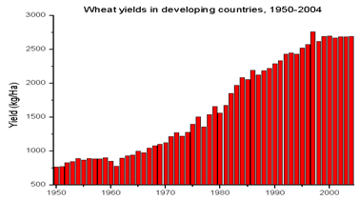
GRAPH 2: (7)
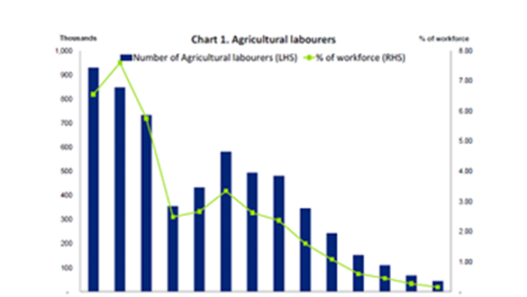
GRAPH 15: (7)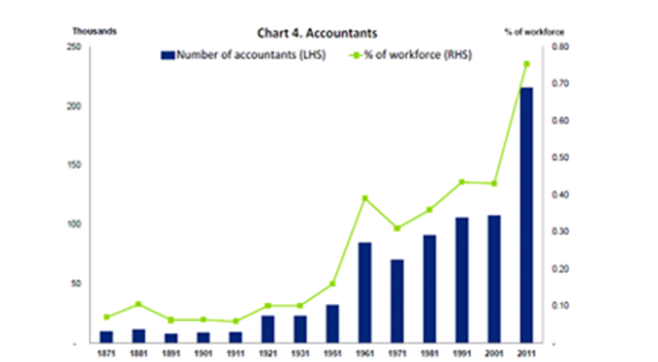

Citations
- Bessen, James. Havard Business Review. How Technology Creates Jobs for Less Educated Workers. March, 21 2014. Web. https://hbr.org/2014/03/how-technology-creates-jobs-for-less-educated-workers
- Chitakasem. Technology In the Workplace: 5 Reasons To Keep Up. Web. https://www.ivyexec.com/executive-insights/2013/5-reasons-to-keep-up-with-technology-in-the-workplace/
- Dukes. Ways that Technology has Changed the Modern Workplace. December 23, 2014. Web. https://www.iofficecorp.com/blog/4-ways-technology-has-changed-the-modern-workplace
- Impacts of Technological Change in Productivity. Boundless. Web. https://www.boundless.com/economics/textbooks/boundless-economics-textbook/economic-growth-20/productivity-98/impacts-of-technological-change-on-productivity-370-12467/https://www.merriam-webster.com/dictionary/technology
- Jonas, Hans. The imperative of responsibility: in search of an ethics for the technological age. Chicago: University of Chicago Press, 1984. Print.
- Kottasova, Ivana. CNN. Technology Could Kill 5 Million Jobs by 2020. January 18, 2016. Web. http://money.cnn.com/2016/01/18/news/economy/job-losses-technology-five-million/
- Makortoff, Kalyeena. Don’t fear the robots, tech creats jobs. August 19, 2015. CNBC. Web. http://www.cnbc.com/2015/08/19/dont-fear-the-robots-tech-creates-more-jobs-than-it-destroys-report.html
- Manufacturing’s Productivity Myth. October 26, 2016. Graph. http://economistsview.typepad.com/economistsview/technology/
- Manufacturing’s Productivity Myth. October 26, 2016. Web. http://economistsview.typepad.com/economistsview/technology/
- Merriam Webster. Accessed May 8, 2017. Web. https://www.merriam-webster.com/dictionary/technology
- Rotman. How Technology is Destroying Jobs. June 12, 2013. Web. https://www.technologyreview.com/s/515926/how-technology-is-destroying-jobs/
- Scott. Importance of Technology in the Workplace. Web. http://smallbusiness.chron.com/importance-technology-workplace-10607.html
- Sharplin. Marby. Does more Technology Create Unemployment?. March 18, 1986. Web. https://www.libertarianism.org/publications/essays/does-more-technology-create-unemployment
- Sherman, Eric. Forbes. Automation Won’t Create Jobs like Technology did in the Past. December 17, 2017. Web. https://www.forbes.com/sites/eriksherman/2016/12/17/automation-has-created-more-jobs-in-the-past-but-will-it-now/#200b432c57cd
- Spandas, Lui. Business Insider. 6 Jobs that New Technologies are Creating. March, 1 2016. Web. https://www.businessinsider.com.au/6-jobs-that-new-technologies-are-creating-2016-3

